**Author: Nicole Okkers**

**Title: Three species of Cordylid species: Intra and Interspecific Head Morphology Variation.**

**Student number: 3409603**

**Due Date: 13 May 2019**

**Introduction**

Cordylids have a large insectivorous diet, that are endemic to South Africa. ( (Mouton & Van Wyk 1997, Broeckhoven 2015). Sit – and – wait for agers are characterised with a very specific hunting/foraging strategy. This strategy consists of resuming an ambush position that is close to a rock or crevice, from which they catch prey over short distances. (Mouton & Van Wyk 1997, Broeckhoven 2015) . As a result, intraspecific competition for similar food resources can become extremely costly for species that are group – living and sit and wait foragers. This is not the same for solitary sit – and –wait – forger species (Broeckhoven 2015). As a result of their variation in body armour, cordylid species can be taxonomically characteristically defined. This includes the extent and arrangements of their osteoderms as well as the length of their keratinous spines. Cordylids are also adapted for a high sprinting capacity (Losos *et al*. 2002).

The ability to hunt, detect, recognise and essentially capture prey can help ecologists determine the diet of an organism (Ferry-graham et al. 2001). An increase in an individual’s ability to capture prey will result in a higher fitness and survival rate. This is achieved as it allows the organism to experience a higher intake of energy per unit effort (Broeckhoven & Mouton 2015). This means that there is a need to investigate the functional mechanisms that are responsible for prey capture. This is crucial for the understanding of the evolution of feeding behaviour (Broeckhoven 2015).

Ecologists are interested in the cranial structure of vertebrate organisms. This is because the cranial structure is an intricate integrated system that is responsible for a variety of behaviours and functions. These include drinking, chemoreception, display defence and feeding ((Broeckhoven 2015). The evolution of head morphology in lizards was hypothesised to be influenced by habitat use. The use of crevices by rock-dwelling lizard species, such as the cordylid, appears to constrain head morphology. This is based on the premise that a tall head morphology could weaken bite performance. This could be a result of alterations in the form of size and relative position of cranial and muscular elements hugely impacts bite force (Losos *et al*. 2002). A reduction in bite force could result in major consequences for a species diet. The reduction in bite size will restructure the proportion of hard prey that is available for ingestion (Losos *et al*. 2002). Previous findings suggest that morphological changes in lizard head morphology could allow rock-dwelling species to adapt and utilise similar prey and dietary resources as Terrestrial Lizard species ((Broeckhoven & Mouton 2015).

The aim of the study is to provide an understanding of the relationship between head morphology and several characteristics of the dietary ecology of the rock-dwelling cordylid lizard species. The three species of closely related cordylid lizards, *Karusasaurus polyzonus, Namazonurus peersi,* and *Ouroborus cataphractus* are classified as strict-rock-dwelling, sit – and - wait foragers (Broeckhoven & Mouton 2015). Cordylids are found throughout their distribution range and are often observed at the same rock crevice sharing resources. The aim is to determine whether differences in head morphology influences aspects of dietary ecology of 3 species of codylids.

**Method & Materials**

Field studies were done in the Matzikama Municipality that is situated in the West Coast district of the Western Cape of South Africa. The study site was in Nuwerus, which is a settlement in Matzikama Municipality. The Matzikama Municipality is situated 70km north-west of Vanrhynsdorp and 16km of Bitterfontein. The site was situated within the Hardeveld, an area that forms part of the succulent Karoo Biome. The succulent Karoo Biome is known to be very rich in Endemic plants.

Samples were collected for 3 species of Cordylids, *O. Cataphractus, k. polyzomas* and *N. peersi* from 2015 to 2017. N = 29 Cor *N. peersi*, N = 43 for *K. polyzonus* and N = 51 *for O. Cataphractus*. The following measurements were recorded for each individual cordylid species: Snout – vent – length (SVL), Head length, which was measured from the posterior edge of the parietal bone to the tip of the snout. The bite force for each individual was also recorded. The bite force measurement was determined by measuring the head volume for each cordylid individual. Measurements were taken using manual callipers, that had a precision of 0.01mm. As a result of the inter- and intraspecific differences in body size, all the morphological variables SVL; Head length; Head volume were regressed against snout-vent length and residuals were calculated with species and their interactions as model effects. Analysis of variances was concluded in R Studio. The significance level was accepted at P < 0.05. Log transformations were performed on the raw but in order to achieve a normal distribution.

**Results:**

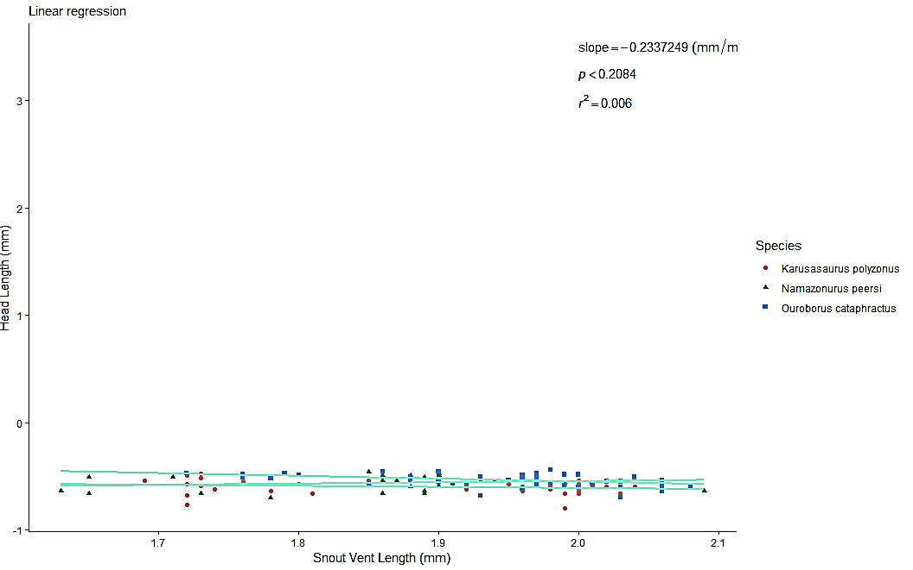

**Figure 1:** Graph illustrating the relationship between the head length and snout-vent length (SVL) between three cordylid species.

Head Length vs SVL

The linear regression analysis for the snout-vent-length vs head length accepts the null hypothesis, with a P value of 0.389. This is a negative linear regression with a slope of – 0.2337.

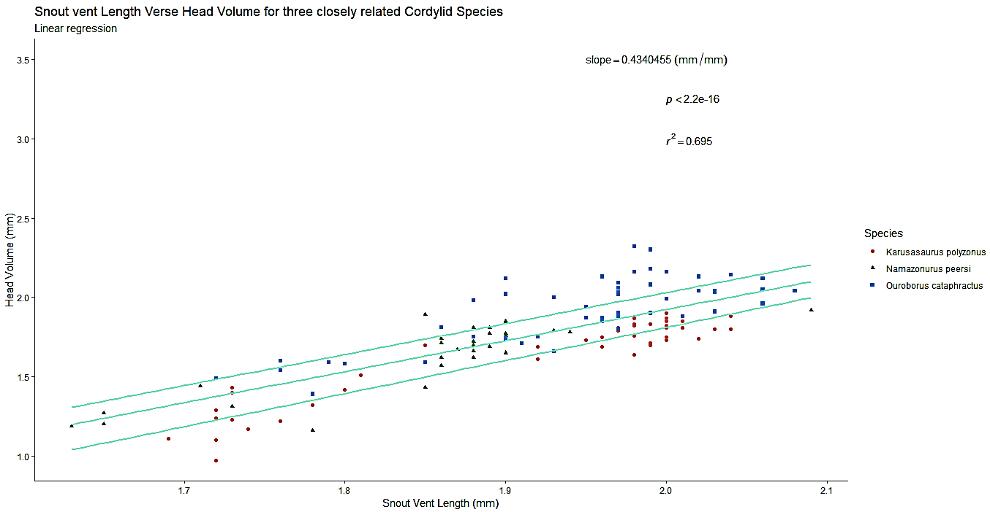

**Figure 2:** Graph illustrating the relationship between the head volume (bite force) and snout-vent length (SVL) between three cordylid species.

Head Volume vs SVL

The Linear regression analysis for snout-vent length and head volume (bite force) rejects the null hypothesis and accepts the alternative hypothesis with a P < 0.05. This means there is a linear regression showing that bite force (Head Volume) is dependent on Snout vent length. *Ouroborus cataphractus* has the highest volume. The slope of the graph is 0.434, making it positive.

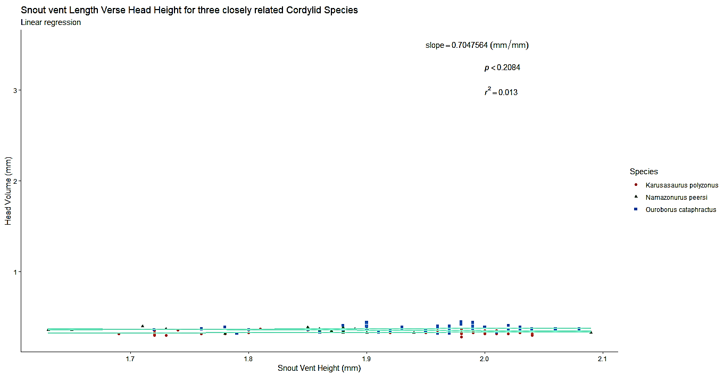

**Figure 3:** Graph illustrating the relationship between the head height and snout-vent length (SVL) between three cordylid species.

Head Height vs SVL

The linear regression analysis for head height and snout-vent length accepts the null hypothesis, with a P value of 0.2084. This is a positive linear regression, with a slope of 0.7047.

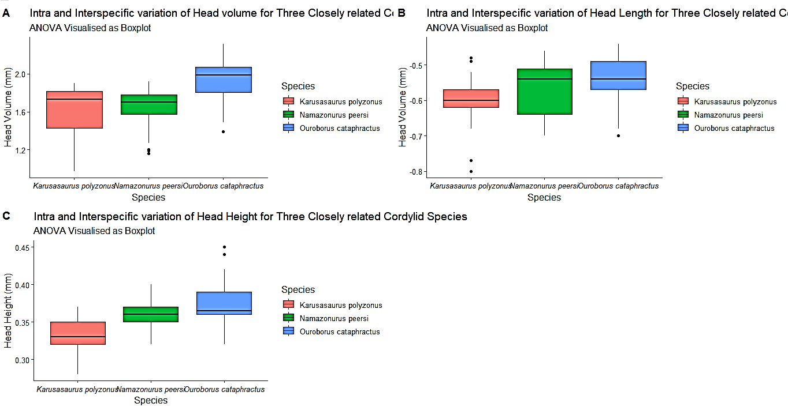

**Figure 4:** 3 Graphs Showing the ANOVA Analysis for the Head Volume (a), Head Length (B) and Head Height (c) for the three different species of Cordylids.

ANOVA Head Volume across Species

This one-way analysis of variance showed a significance difference in head-volume morphology across the three species. (Fig 4a). The null hypothesis was rejected and the alternative hypothesis accepted, with P < 0.05. The Tukey post-hoc test showed that there was no significant difference in head volume between *Namazonuius peersi* and *Karusasaiurus polyzonous*, P = 0.985. The test also shows that there are significant differences in head volume between *Ouroborus Cataphractus* and *Karusasaiurus polyzonous*, as well as *Ouroborus cataphractus* and *Namazonuius peersi* P < 0.05.

ANOVA – Head Length across Species

The one-way analysis of variances showed a significant difference in head length morphology across the three species (Fig 4b). The null hypothesis was rejected and the alternative hypothesis accepted, with P < 0.05. The Tukey post hoc test showed that there was no significant difference in head length between *Ouroboros cataphractus* and *Namazonuius peersi*, with p = 0.12. The test showed that there are significant differences in head length between *Namazonuius peersi* and *Karusasaiurus polyzonous,* with p = 0.225 and *Ouroborus cataphractus* and *Karusasaiurus polyzonous*, with P < 0.05.

ANOVA – Head Height across Species

The one-way analysis of variances showed a significant difference in Head Height across the three different species (Fig 4c). The null hypothesis was rejected and the alternative hypothesis accepted with p < 0.05. The Tukey post hoc test shows that there are significances in head height across all groups with *Namazonuius peersi* and *Karusasaiurus polyzonous* p < 0.05*. Ouroborus cataphractus* and *Karusasaiurus polyzonous* p < 0.05 and *Ouroborus cataphractus* and *Namazonuius peers*i , p = 0.028.

**Discussion:**

Figures (1-3) show that there is a weak relationship between head length and head height and snout-vent length. This means that Head Length and Height are not dependent on the species’ snout vent length. This is not the case for head volume. Bite force is dependent on Snout vent Length. All three species seem to have similar head lengths despite *Namazonuius peers*i being the smaller species of the three. The strong positive regression between SVL and head volume (Fig 2), infers that there is intra and inter specific variation between the three closely related cordylid species. Figure, shows that *Ouroborus cataphractus* has a larger head height out of the three cordylid species and that head height is small for all three cordylid species.

Figures (4a-c), show that the head morphology differ across all three species of cordylids. This shows that inter & intraspecific variation is experienced by these three closely related species.

Figures (4a – 4b) show that all three cordylid species display some difference in head morphology across species. However, the only significant difference is seen with SVL and Head Volume. Some research argues that the absolute bite forces that are observed in most cordylid species, exceed the rigidity of the prey that is mostly available. (Mouton & Van Wyk 1997, Broeckhoven 2015). An example of this is that lizards that consume arthropods as food, do not exert more than 10N of energy. With the exception of very hard Coleoptera species (Broeckhoven 2015). As a result, bite force should only have a slight impact on dietary Niche Portioning. The non-significant results shown in (figures 1 and 3), infer that there is an additional selection pressure that could act on the bite force in lizards. One possibility to consider, is that some species bite force might be an adaptation for anti predator defence, instead of aiding the species with the handling of prey (Herrel et al. 2001). The relatively high head volume (bite force) in *O. cataphractus* (figure 2), is postulated to be related to its unique tail biting behavioural act. This act is only displayed by this cordylid species (Mouton & Van Wyk 1997). Ecologists suggest that the head height could be limited by rock-dwelling behaviour. This is based on the premise that the possession of a tall head and associated use of wider crevices, might increase the risk of exposure to predators (Herrel et al. 2001). As a result, a decrease in head height could in turn decrease bite force, as less area becomes available for muscle attachment (Herrel et al. 2001).

These three species of cordylids are closely related and are characterised as rock-dwelling-sit-and-wait foragers (Broeckhoven 2015). These three species are frequently observed sharing and utilising the same rock crevices and they co-occur throughout their distribution range (Broeckhoven 2015). *Karusasaurus polyzonus,* *Namazonurus peersi* and *Ouroborus cataphractus,* however, strongly differ in many components of their behaviour and morphology (Herrel et al. 2001). Some research suggests that the head width could be an important predator of bite force in *Karusasaurus polyzonus* and *Namazonurus peersi* (Losos *et al*. 2002). This was not tested in this study, but it would be beneficial to test in the future. Contradictory to head width, head height is the strongest predictor of bite force in *Ouroborus cataphractus* and significant inter and intraspecific variation in head height is present in the three species (Broeckhoven 2015). This suggests that an increase in any head dimension (length, width, height), could improve bite force. This is achieved through the increased space that is provided to accommodate musculature. An increase in head height could thus further enhance bite force through increasing the physiological cross-section of the jaw-adductor muscles (Herrel et al. 2001).

Interspecific variation in head height, could be a result of the differences in habitat or predation pressures for rock dwelling xenosaunrids (Herrel et al. 2001). The results of this study seem to agree with the aforementioned statement (Figure 4c). The three closely related cordylid species co-occur and co-exist throughout their entire distribution range and as a result, experience similar predation pressures (Broeckhoven 2015). Interspecific variation in head height that has been observed for these three species could possibly be related to their antipredator morphology (Broeckhoven 2015). Interspecific variation is happening, as the ANOVA and Tukey results for figures 4a-c show. In order to avoid predation via extraction, cordylid lizards typically position their bodies parallel to the crevice opening. Thus, using its tail to block access, which prevents predation (Herrel *et al*. 2001a). The presence of long tail spines and the heavy armour of *O. cataphractus*, could potentially allow an increase in head height without increasing extraction (predation) risk. This enables individuals to gain and develop a stronger and higher bite force (Herrel *et al*. 2001a).

In conclusion, the data show that there is inter and intraspecific variation amongst head morphology for the three different species. There only seems to be significant differences between bite force and SVL for the three different regression analysis. This suggests that a high bite force could benefit tail-biting behaviour as well as influencing the ability to exploit some of the hardest prey available in the habitat. This lowers inter-specific completion for food.

**References**

Broeckhoven, C. 2015. Causes and consequences of body armour in the group-living lizard , Ouroborus cataphractus ( Cordylidae ) by.

Broeckhoven, C. & Mouton, P. F. N. 2015. Hit or miss : Functional mechanisms underlying prey capture ef fi ciency in three cordylid lizards. *Journal of Arid Environments* 120:72–74. Elsevier Ltd.

Ferry-graham, L. A., Wainwright, P. C. & Bellwood, D. R. 2001. Prey capture in long-jawed butterflyfishes ( Chaetodontidae ): the functional basis of novel feeding habits. *Journal of Experimental Marine Biology and Ecology* 256:167–184.

Herrel, A., Damme, R. Van, Vanhooydonck, B. & Vree, F. DE. 2001. The implications of bite performance for diet in two species of lacertid lizards. *Canadian Journal of Zoology* 79:662–670.

LosoS, J. B., Mouton, P. L. E. F. N., Bickel, R., Cornelius, I. A. N. & Ruddock, L. 2002. The effect of body armature on escape behaviour in cordylid lizards:313–321.

Mouton, P.LE F.N and Van wyk, J. . 1997. Adaptive radiation in cordyliform lizards : An overview Adaptive radiation in cordyliform lizards : An overview. *African Journal Herpetology* 46:78–88.

Mouton, F. N., Geertsema, H. & Visagie, L. 2000. Foraging mode of a group-living lizard , Cordylus cataphractus ( Cordylidae ). *African Zoology* 35:1–7.

Mouton, P. F. N., Flemming, A. F. & Kanga, E. M. 1999. Grouping behaviour , tail-biting behaviour and sexual dimorphism in the armadillo lizard ( Cordylus cataphractus ) from South Africa. *Journal of Zoology* 249:1–10.